Home Learning Task: Build Your Own Ancient Egyptian Settlement

Your Mission:
Imagine you are living in Ancient Egypt thousands of years ago. Your task is to design your own Ancient Egyptian settlement beside the River Nile.
Think carefully about where people would live, how they would get food and water, the jobs they might do and what would be important to their community.
Step 1: Have a Think... (5 minutes)
Before you begin, think about these questions:
- Why was the River Nile so important to the Ancient Egyptians?
- What do you think Ancient Egyptian homes were like?
- What jobs might people have had?
- How would everyday life have been different from your life today?
You could discuss your ideas with someone at home.

Step 2: Research and Plan (10–15 minutes)
Use what you have learnt in school or do a little research to help you plan your settlement.
Find out or think about:
- 🏠 Homes: What were houses made from? What might you find inside them?
- 🌾 Food and farming: What crops did the Ancient Egyptians grow? How did the River Nile help them?
- 🐄 Animals: What animals might people have kept or seen?
- 👩‍🌾 Jobs: Think about farmers, builders, craftspeople, scribes, soldiers and traders.
- 🍞 Daily life: What did people eat, wear and do?
- ⛵ Travel and trade: How might people use the River Nile to travel and move goods?
- 🛕 Religion: Where might people worship their gods and goddesses?

Step 3: Design Your Ancient Egyptian Settlement (30 minutes)
On a sheet of paper, draw your Ancient Egyptian settlement.
Remember, the location of your settlement is important. Think carefully about where you will put the River Nile and why people might want to live close to it.
Try to include:
- 🏠 Houses and other buildings
- 🌊 The River Nile
- 🌾 Fields and crops
- 🌴 Plants and trees
- 👨‍🌾 People carrying out different jobs
- 🐂 Animals
- ⛵ Boats for travel, fishing or trade
- 🛕 A place of worship
- 🧺 Objects or tools people might use in everyday life
Challenge
Add labels explaining different parts of your settlement.
For example:
I have placed the fields close to the River Nile because...
The people who live here use this building for...
This person is a _______. Their job is to...
Try to make your settlement historically accurate, rather than including things that would not have existed in Ancient Egypt!

Step 4: Reflection (5–10 minutes)
Write 4–5 sentences about your settlement.
Use these questions to help you:
- Why did you build your settlement near the River Nile?
- What do you think is the most important part of your settlement? Why?
- What jobs would the people in your settlement do?
- What would you enjoy about living in Ancient Egypt?
- What do you think would be difficult compared with life today?

Year 4 Home Learning: Multiplication Challenge
Please make sure that you set out your work neatly and show your working out.

A – Warming Up…  - 3 × 4 = ______  - 5 × 6 = ______  - 4 × 7 = ______  - 8 × 2 = ______  - 10 × 9 = ______  - 3 × 8 = ______  - 6 × 4 = ______  - 5 × 11 = ______  - 7 × 3 = ______  - 12 × 2 = ______ | C – Getting Trickier…  - 21 × 3 = ______  - 32 × 4 = ______  - 41 × 5 = ______  - 23 × 6 = ______  - 34 × 3 = ______  - 42 × 5 = ______  - 24 × 4 = ______  - 31 × 7 = ______  - 43 × 6 = ______  - 52 × 4 = ______
B – Keep going…  - 6 × 7 = ______  - 8 × 4 = ______  - 9 × 6 = ______  - 7 × 8 = ______  - 12 × 4 = ______  - 8 × 8 = ______  - 9 × 7 = ______  - 6 × 12 = ______  - 11 × 7 = ______  - 12 × 8 = ______ | D – More of a Challenge…  - 124 × 3 = ______  - 213 × 4 = ______  - 142 × 5 = ______  - 236 × 3 = ______  - 157 × 4 = ______  - 268 × 3 = ______  - 175 × 5 = ______  - 294 × 3 = ______  - 186 × 4 = ______  - 247 × 6 = ______

If you have any spare time, please play Times Table Rockstars

The Hidden Caves of Ember Island
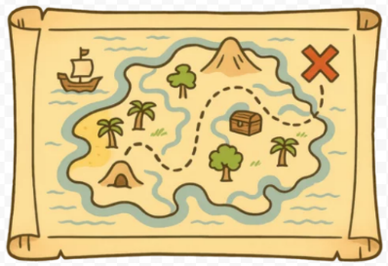
Leo tightened the straps of his rucksack and squinted at the mysterious map in his hands. The paper was yellowed with age, and its edges were torn, but the red X in the corner was still clear. According to the old legend, the X marked the hidden treasure of Ember Island.
“Are you sure this is a good idea?” asked Mia, his best friend, brushing sand from her shoes. “The waves are strong, and the forest looks dangerous.”
“That’s what makes it an adventure,” Leo replied, his eyes gleaming with excitement.
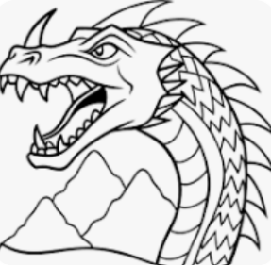
The children leapt from their small wooden boat onto the sandy shore. Behind them, the sea roared like a wild beast, tossing the boat up and down as though it wanted to swallow it whole. Ahead of them, the island’s jungle stretched out, dark, tangled, and humming with unknown sounds. Birds screeched overhead, as if warning them to turn back, and crabs scuttled quickly across the rocks.
Leo led the way, holding the fragile map tightly. They pushed through thick vines, their feet sinking into the damp earth, and ducked under branches that clawed at their clothes. The air grew hotter and stickier with each step. Suddenly, they reached a rocky cliff face. On the stone, strange carvings showed spirals, arrows, and the outline of a dragon with its mouth wide open.
“Do you think it’s a clue?” Mia whispered, her eyes wide.
Before Leo could answer, a deep rumble echoed from within the cliff. The ground shuddered beneath their feet, and with a loud creak, a narrow passage slowly opened in the rock. A cool draught of air drifted out, carrying the smell of earth, moss, and mystery.
Leo grinned. “The treasure must be inside. Come on!”
Mia hesitated for only a moment before following him into the darkness. The tunnel walls glittered faintly as though tiny stars were trapped in the stone. Water dripped from the ceiling, echoing in the silence. After a few steps, they reached a fork in the passage. One path sloped downward into shadows, while the other curved steeply upwards.
Leo glanced at the map again. “The dragon’s mouth… it points left,” he muttered.
They followed the left-hand path, the air growing cooler as they went. At last, they stumbled into a wide cavern. Torches, long extinguished, lined the walls, and in the centre stood a stone pedestal. On it rested a small chest, its golden surface glimmering faintly in the dim light.
Leo’s heart pounded. They had found it. But just as he reached out, the cavern filled with a low growl, and two fiery eyes flickered open in the shadows…

Questions
1. Find and copy one word from the text that means the same as fragile. (1 mark)

2. What shape was carved on the cliff face along with spirals and arrows? (1 mark)

3. What did Mia do before following Leo into the passage? (1 mark)

4. How do you know the jungle was an unfriendly place to explore?
Give two pieces of evidence from the text. (2 marks)

5. Why do you think Leo’s eyes were “gleaming with excitement” at the start of the story? (2 marks)

6. The tunnel walls “glittered faintly as though tiny stars were trapped in the stone.” What picture does this create in your mind? (1 mark)

7. What do you think the fiery eyes in the cavern belong to? Explain why you think that. (2 marks)

8. What is the main problem the children face at the end of the text? (1 mark)

Year 4 Home Writing Task: A Journey into the Storm
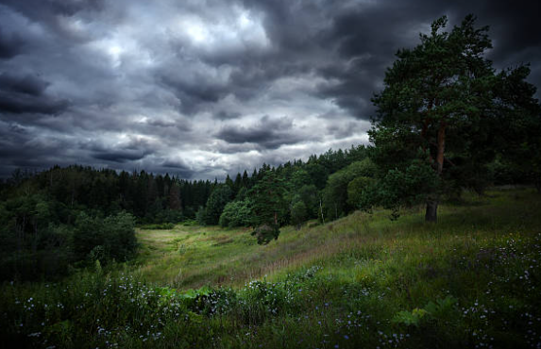
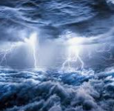

Write an adventure story about travelling through a powerful storm to reach a new destination.

Your story should include:
- A description of the stormy setting (what you can see, hear, feel)
- At least two characters
- A problem caused by the storm
- An ending (safe escape, or a cliffhanger…)

Step 1: Warm-up (10 minutes)
Practise a few sentences before you start your story.
1. Write three sentences describing stormy weather. | The wind howled through the trees.
2. Write three sentences that show a character is brave. | He clenched his fists and stepped forward.
3. Write three sentences that show danger is near. | A sudden crash of thunder made her jump.

Step 2: Planning (10 minutes)
Use these questions to plan your story:

- Who are your characters? (friends, a family, explorers, sailors…)
- Where are they? (on a ship, in the mountains, on a journey…)
- What happens in the storm? (lightning, flooding, trees falling, shipwreck…)
- What is the problem? (they get lost, trapped, or nearly injured…)
- How will your story end? (safe escape, rescued, or a cliffhanger).
You could draw a quick story map or jot down bullet points.

Step 3:
Here are some stormy adventure words to help you:
Vocabulary Bank
Weather words:  roaring wind  pelting rain  booming thunder  dazzling lightning  swirling clouds  howling storm | Feelings:  terrified  shivering  hopeful  exhausted  nervous  cautious  thrilled | Powerful action words (verbs):  battled  clutched  scrambled  stumbled  dashed  shouted  trembled  braced

Step 4: Writing (30 minutes)
Write your story in four paragraphs:

Paragraph 1 – Introduction | Introduce your characters and the storm beginning.
Paragraph 2 – The storm grows | Describe how the weather gets worse. Show how the characters feel and what they do.
Paragraph 3 – The problem | Something dangerous happens because of the storm.
Paragraph 4 – Resolution/Ending | How do the characters solve the problem? Or will you end with a cliffhanger?

Step 5: Editing (10 minutes)
When you finish, check:
- Have I used adventurous vocabulary?
- Do I have capital letters, full stops, and question marks where needed?
- Have I used different sentence openers? (Suddenly… In the distance… Without warning…)
- Have I written at least one page?

